Intended Users: | Consumers | Information Professionals | Researchers

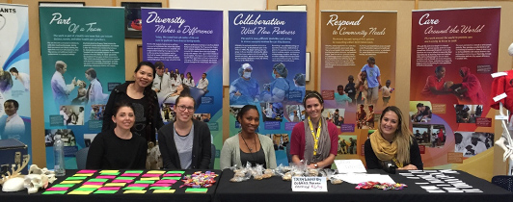
NLM Exhibitions
Description: NLM Exhibitions enhance awareness and appreciation of NLM’s trusted health information resources. Featuring NLM’ s rich collections, exhibitions showcase centuries of medical knowledge. Exhibitions explore the relationship between medicine and the arts, science and society, patients and practitioners, and the technology of medicine. Online exhibitions and traveling exhibitions are available. NNLM offers the graphic, roll-up banner displays for traveling exhibitions free of charge. Exhibitions feature curated selections of digitized books, images, ephemera, films, and historical documents from the NLM Digital Collections. Booking length is typically 6 weeks. Calls for requests occur on the exhibition listserv. Bookings are typically made several months to years in advance.

Popular uses of this product:
Consumers | Information Professionals | Researchers
- Visit an exhibition at your local library and explore the intersection of history, society, culture, and medicine.  - Educators can incorporate modules and learning activities from online exhibitions into lesson plans.  - View online exhibitions to learn about cultural history, medicine, and NLM resources. | - Request an NLM Traveling Exhibition for display at your institution.  - Create programing around online exhibits to teach patrons about the history of medicine and NLM resources.  - Review the Making Exhibition Connections Blog to discover ways institutions have partnered to foster health literacy. | - Explore exhibitions to learn about the history of medicine and the impact of culture on health care and well-being.  - Partner with the NNLM for training or funding to host an NLM Traveling Exhibition.  - Host events and stream upcoming or archived History of Medicine lectures featuring  exhibition curators.

Key Points:
- Expert curators create thought-provoking exhibitions from NLM resources and digital collections that can be featured and displayed at libraries and cultural institutes across the United States.
- Institutions and educators can incorporate the online exhibitions into their teaching or request an NLM Traveling Exhibition to promote health literacy and awareness of NLM resources.

Considerations:
- Traveling exhibition hosts are responsible for arranging and paying for outgoing shipping to the next host venue via a trackable service ($200 - $1,000 estimated cost).

Teaching Examples:
- Explore “Renaissance Science, Magic, and Medicine in Harry Potter’s World” and its public programming examples. Brainstorm ways the exhibition could be used to create library programming.
- View “Surviving and Thriving: AIDS, politics, and culture.” Explore the digital gallery and look at the
advertisements used to promote awareness of the AIDS epidemic.

Real Life Examples:
- A university librarian partners with their College of Public Health and requests to host the exhibition “Making a World of Difference: Stories about Global Health” at their institution to encourage students to explore careers in medicine and public health.
- A teacher uses the online activities and resources from the exhibition “Immigrant Health, Health Services, and History” to teach students about healthcare and immigration in the early 1900s.

More Information:
Making Exhibition Connections listserv About NLM Exhibitions

