MLA Course Approval Guide
Follow the steps below to get your LIS or iSchool class MLA approved to offer CHIS certificates.
- Contact Sam Nunn at NNLM and Jim Westwood from MLA to notify your interest in applying to get your course approved to become an MLA consumer health information course.

- Email Jim Westwood your course syllabus and a description of how the course covers one or more of the eight CHIS competencies for review. You are welcome to use the table located on page 3 to describe which competencies the course covers. For more information about the CHIS competencies, visit mlanet.org to learn more.

- Once Jim Westwood verifies that your course aligns with one or more CHIS competencies, go to the MLA application portal to fill out your application. Note that you do not have to be an MLA member to apply. You will need to have an MLA account to complete the form. To request a free guest account, go to www.mlanet.org/r/us/ to get started.

- Throughout the process, please keep in touch with Jim and Sam on the status of your application. If you have any questions about the required information, please contact Jim Westwood or Sam Nunn for assistance.
- Once you've submitted the form, notify Jim Westwood and Sam Nunn of your completion. MLA will review your application, and a representative will contact you about your submission.

Items to keep in mind as you fill out the form
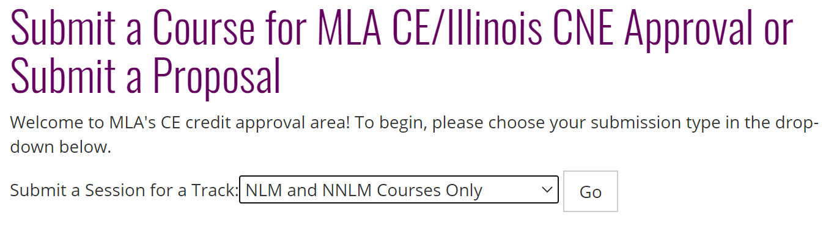
When choosing the submission type, select "NLM and NNLM Courses Only." This selection helps MLA identify if you are participating in the Consumer Health Library Students program.
When you have reached the “MLA CE Credits” section of the form, it will ask you to indicate how many MLA CE hours you seek approval. The CE hours can be determined by the number of hours of in-person work done in the class. One hour of in-person work is equivalent to one CE credit.
MLA CE Credits:  (required) | For how many MLA CE hours are you seeking approval? If you are seeking multiple options depending on your course length, ensure your timed agenda lists specifics for each course length.

When you have reached the term approval section, it will ask you to indicate how long you would like your course to be eligible for MLA CE. Click the drop-down button and choose "3 years". The program offers to cover all the fees related to having your course offer MLA CE credit for up to 3 years.

Term for approval **:  (required) | Indicate how long you want your course to be eligible for MLA CE approval.  Full fee schedule for approval and listing on MEDLIB-ED are available on MLANET (link opens new tab).

If the application gets approved, below are some items to keep in mind for the future.

If you are planning to teach your class again, you will need to fill out the “Schedule a Course on the MEDLIB-ED" form to schedule the course on MEDLIB-ED before the semester begins. This form notifies MLA that you are teaching the class again. They will generate a new code for you to give to your future students to claim credit after completing the course.

When you click on the link, it will take you to the "Schedule a Course on the MEDLIB-ED" page. When you click the drop-down button, choose "I am an NLM or NNLM representative scheduling a course" before proceeding to the form. Once you've submitted the form, MLA will process it and list it on their website. An MLA representative might contact you for additional information if necessary.

MLA Competency | Elements of the course that support this area
1. Know the Community

2. Know the Health Consumer

3. Knowledge of Subject Matter and Resources

4. Evaluation of Health Information

5. Communication, Reference, and Instruction

6. Literacy and Health Literacy

7. Technology and Health

8. Ethical and Legal Issues

